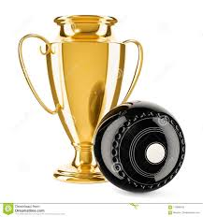

Sunday, 27 March 2022

9:00am

Women’s and Men’s Championship singles

1:00pm

Men and Women’s Championship Pairs

Division 2 Singles

BBQ provided Bar open

Sunday April 3rd

9:00am Womens 100 up

1.00pm Women’s Championship Pairs 

And other matches to be allotted.

Sunday 3rd April

9:00 am Women’s 100 up

1:00 pm Women’s Championship Triples

And other matches as needed

